Assignment 3: Azure Infrastructure
Create 2 GitHub repositories:
- TyesonMach/SD6116_MSA – Application
- TyesonMach/SD6116_azure_infrastructure – Azure terraform infrastructure

After using Terraform to provision resources, we have these resources in the resource group playground-toanmachcanh, including ACR, AKS, and Vnet (since I am using a client-provided account, I cannot show the Subscription information)

Azure Resources
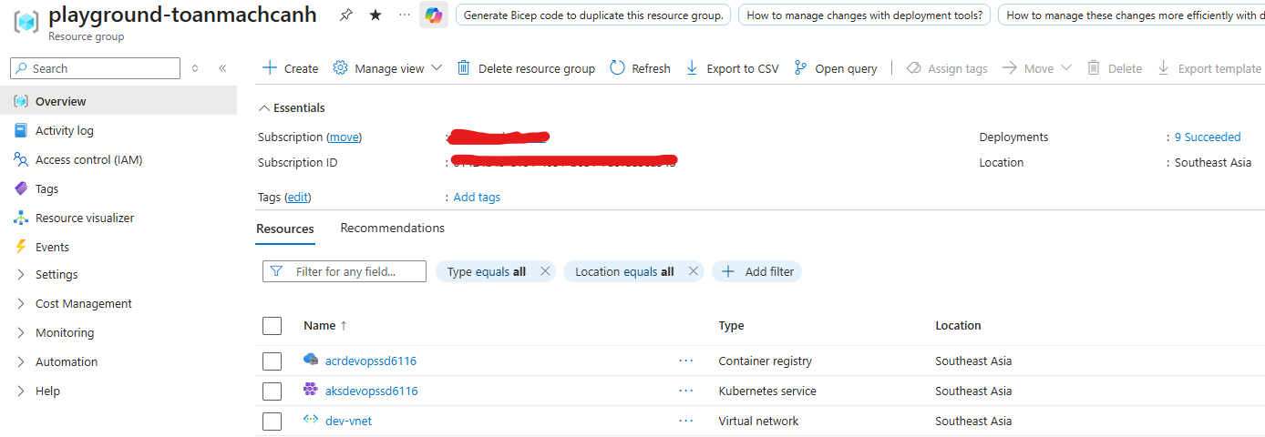
ACR
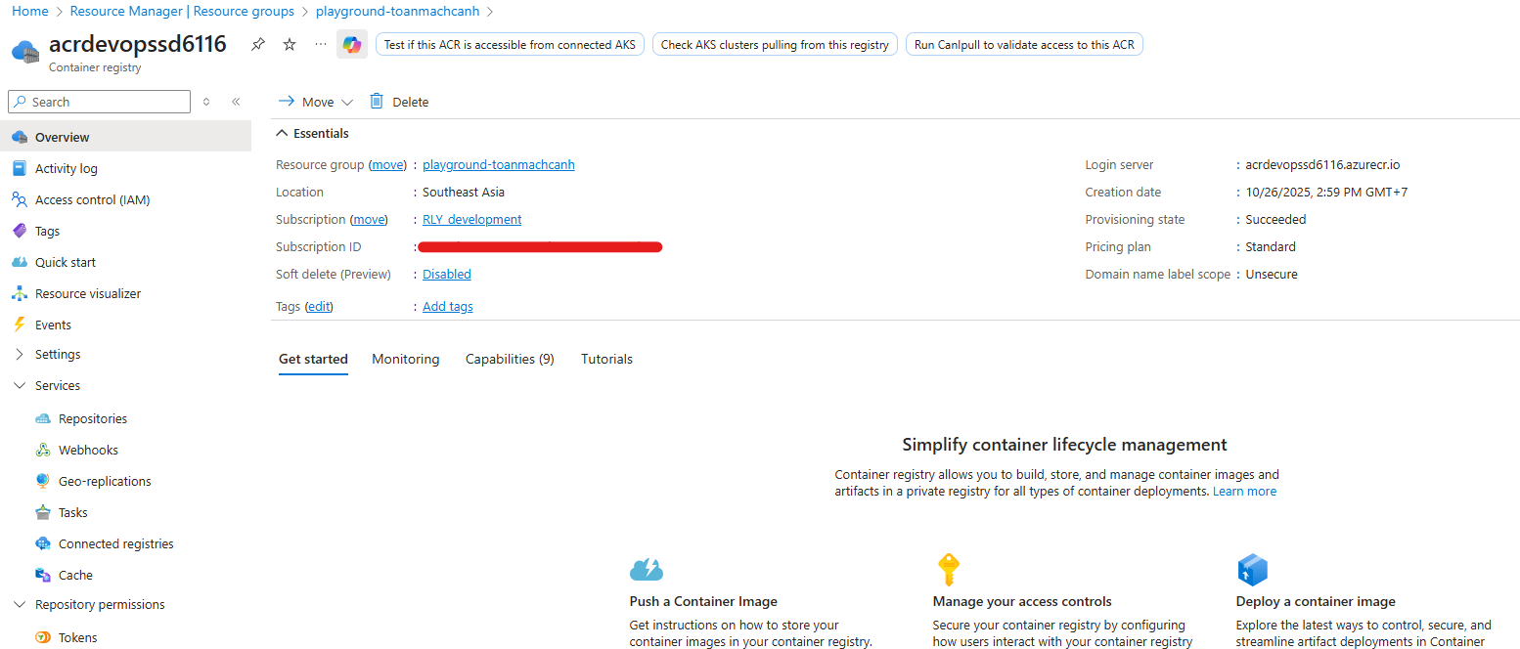

AKS
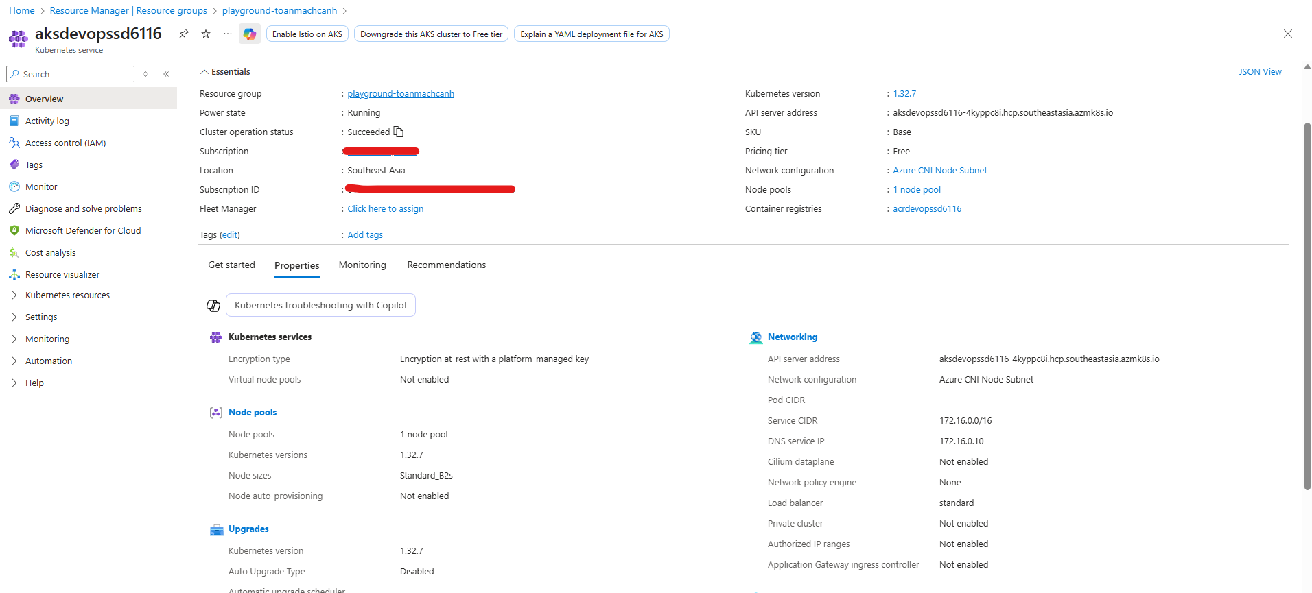

Open the AKS using lens application
In the AKS, I have created 2 primary namespaces
- dev: application pods (backend, frontend, Ingress controller, MongoDB),
- monitoring: Grafana and Prometheus pods,
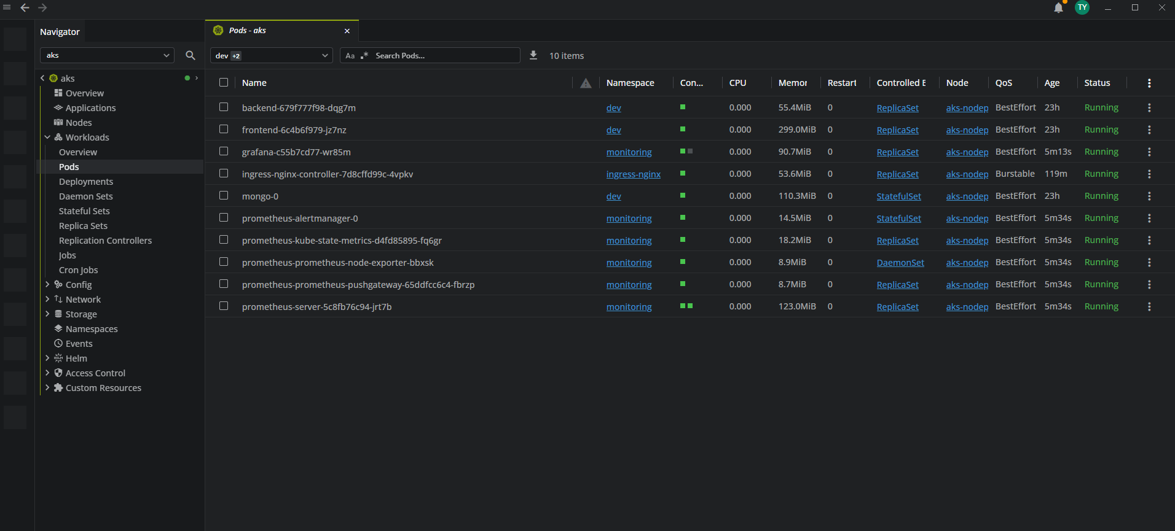

Azure Devops
Create service connections, including acr-conn, aks-conn, and the MSA GitHub repository.
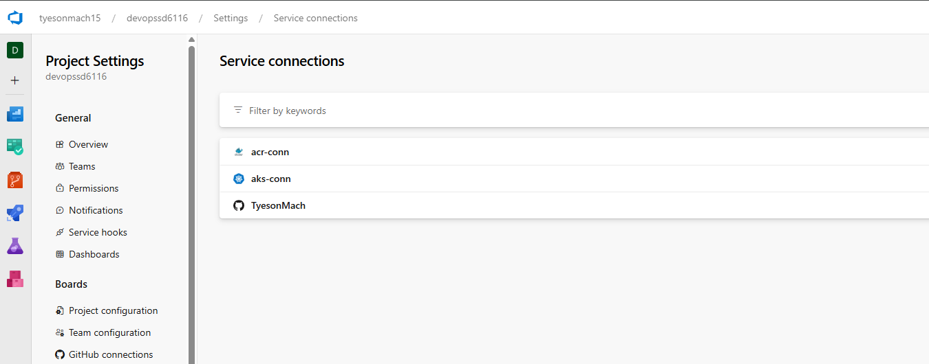
Create and run the pipeline (using azure-pipelines.yml in the MSA GitHub repository)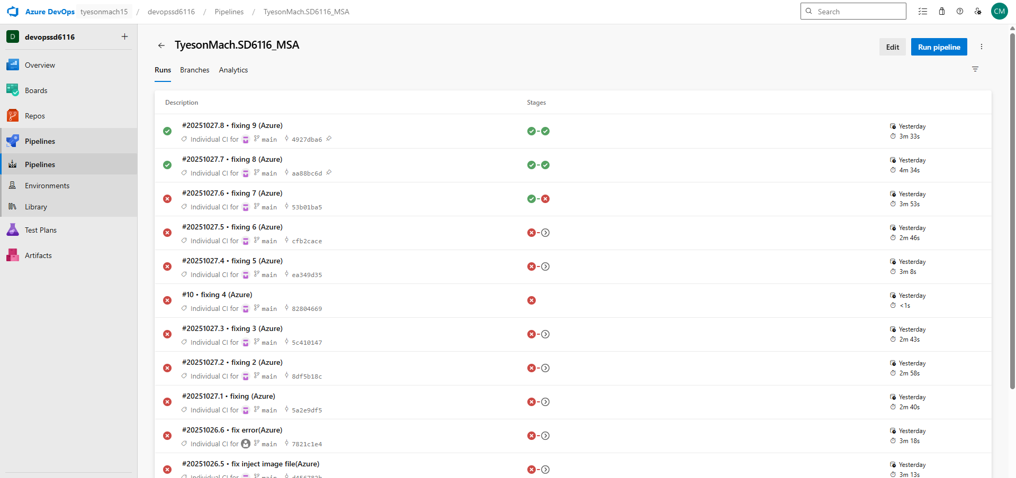

Pipeline when it run successfully
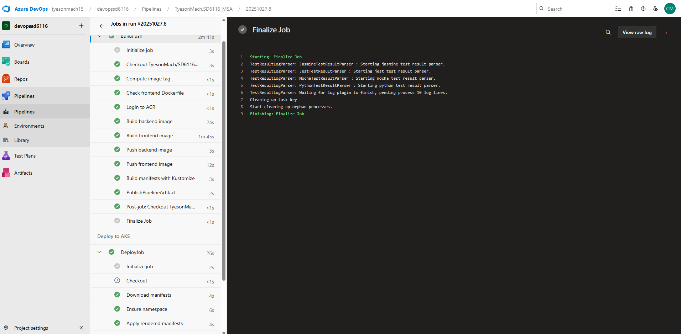

Try to connect the website:
Download the Ingress Controller and get external IP
helm repo add ingress-nginx https://kubernetes.github.io/ingress-nginx
helm repo update
helm upgrade --install ingress-nginx ingress-nginx/ingress-nginx \
--namespace ingress-nginx --create-namespace
# Wait for external IP
kubectl -n ingress-nginx get svc ingress-nginx-controller -w
Then access the website using http://<EXTERNAL-IP>/ (here is https://20.6.121.157)
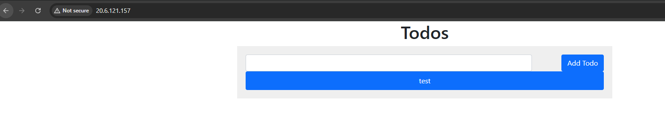

Setup Grafana and Prothemeus:
Using the block of code to install Grafana and Prometheus on the AKS
# 1) Namespace
kubectl create namespace monitoring --dry-run=client -o yaml | kubectl apply -f -

# 2) Add repo Helm
helm repo add prometheus-community https://prometheus-community.github.io/helm-charts
helm repo add grafana https://grafana.github.io/helm-charts
helm repo update

# 3) Install Prometheus
helm install prometheus prometheus-community/prometheus -n monitoring

# 4) Install Grafana and expose by LoadBalancer
helm install grafana grafana/grafana -n monitoring \
--set adminUser=admin \
--set adminPassword=admin123 \
--set service.type=LoadBalancer \
--set persistence.enabled=true \
--set persistence.storageClassName=managed-csi \
--set persistence.size=5Gi

# 5) Get Grafana public IP
kubectl -n monitoring get svc grafana -w
# Open http://<EXTERNAL-IP> (user/pass: admin / admin123)

Access to the Grafana website
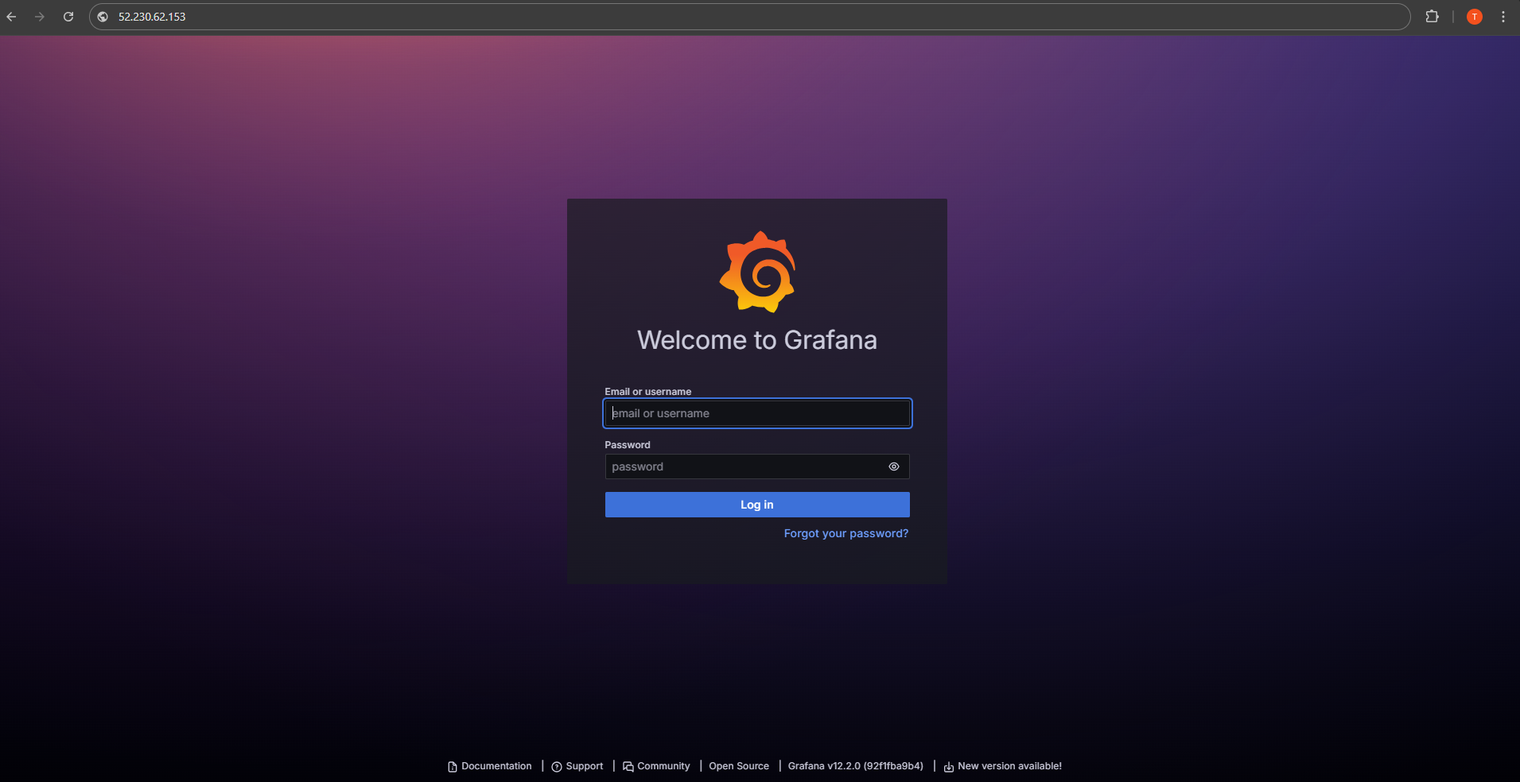
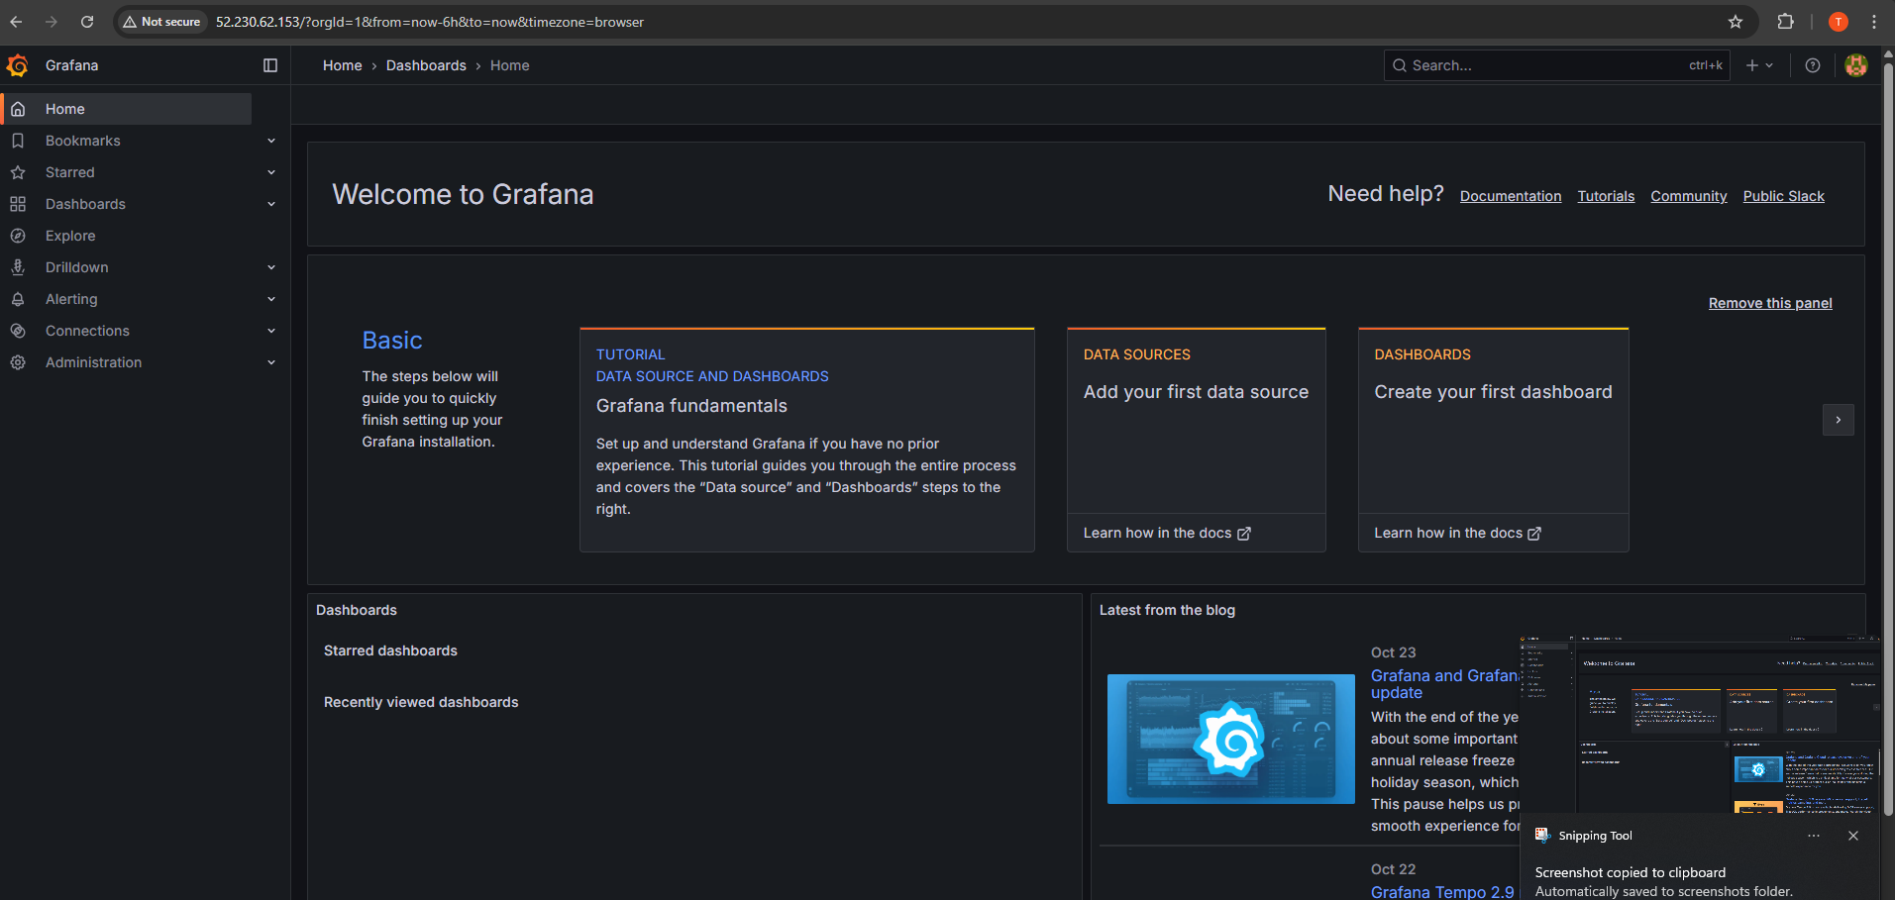
Click the Add your first data source
Then choose Prometheus as the data source
Connection server URL: http://prometheus-server.monitoring.svc:80
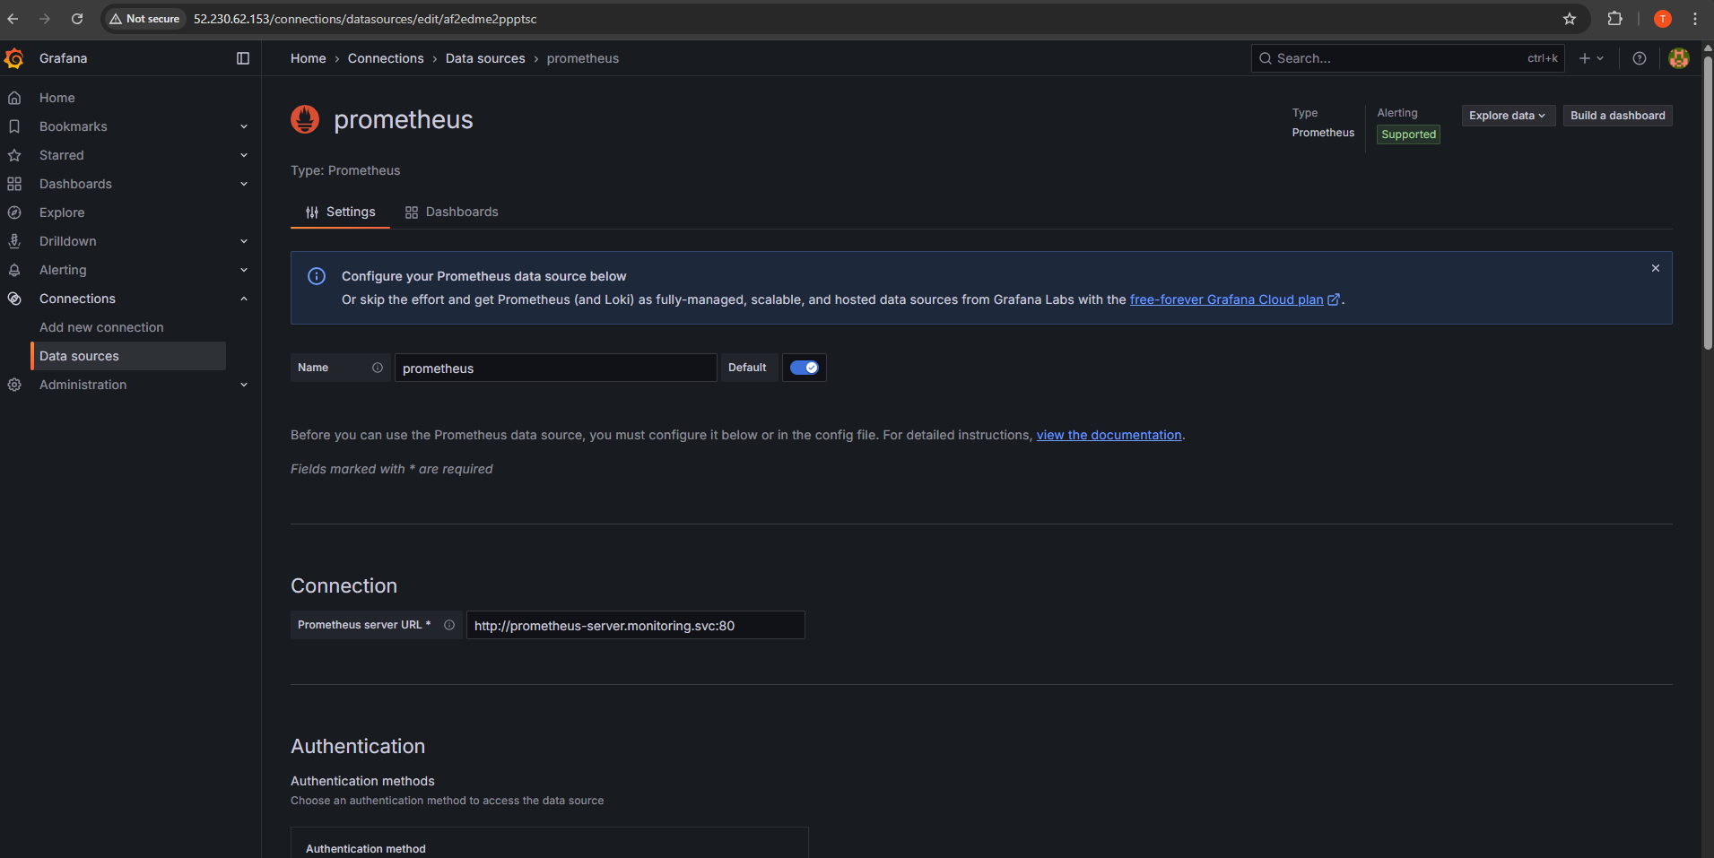
Click Save and Test
Then go to Dashboard -> Import Dashboard -> Choose data source Prometheus
After creating the Dashboard
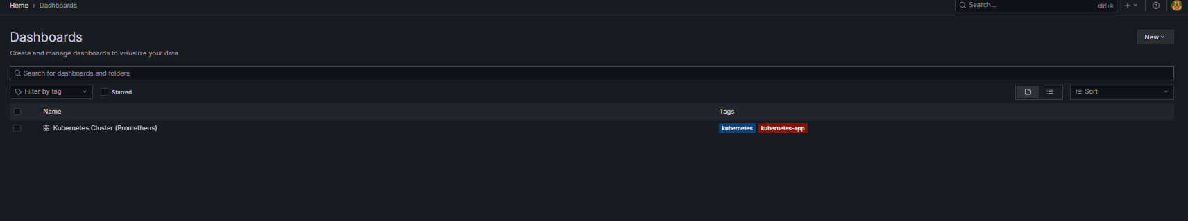
Dashboard UI
